Handbook for Property Owners
2019
West Devil Lake
Property Owners Group
Website: www.westdevillake.ca Contact Board: wdlpog@gmail.com
Facebook: West Devil Lake Group

Table of Contents
Table of Contents 2
Introduction 3
In Case of Emergency 4
Lanes & Roads 6
Caring for the Environment 7
Water Safety and Regulations 9
Fire Safety 10
First Aid 11
Garbage and Recycling 12
Being Good Neighbors 14
Map of West Devil Lake 15

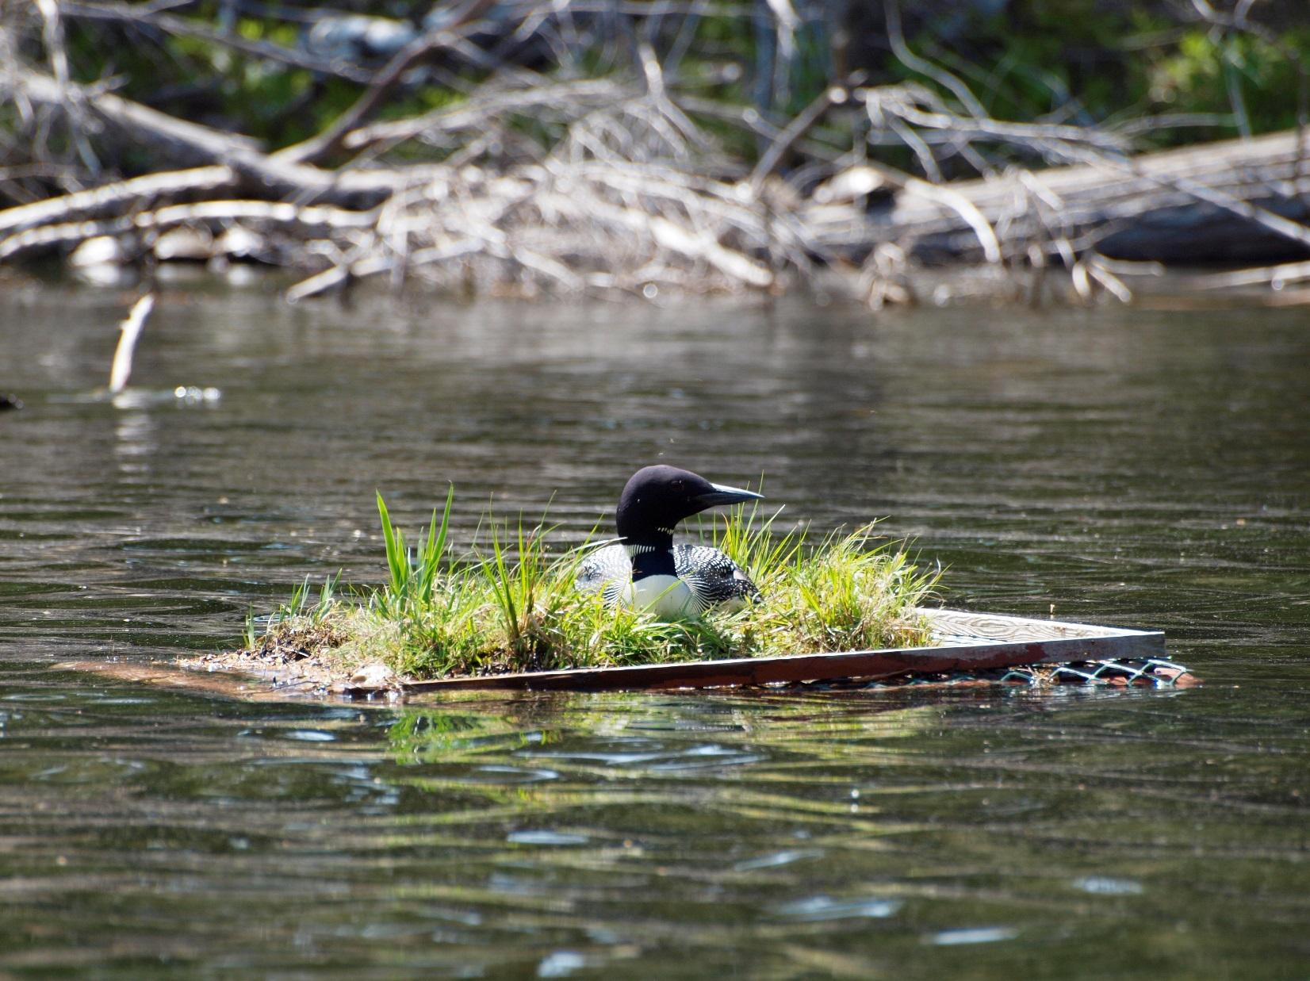

Introduction

The purpose of this handbook is to provide information to property owners and their guests to help promote their safety, security and happiness at West Devil Lake.

West Devil Lake became a cottage community in the early 1960s when lakefront lots were first sold. By the end of the decade the need for a property owners association became apparent, and in 1971 the West Devil Lake Property Owners Association was formed. In 1995 the association changed its name to the West Devil Lake Property Owners Group (WDLPOG), incorporated in 1997.

The primary function of the WDLPOG is to give all property owners an active voice in the ongoing well-being of the community. The WDLPOG operates in accordance with its Bylaw #1, adopted as amended at the July 1, 2017 Annual General Meeting. The WDLPOG maintains the access roads (outside of winter conditions), communicates with local government, advocates for the environment, keeps members informed of items of importance and/or interest, provides a Solid Waste & Recycling Site, tests the lake’s water quality, and works to promote an atmosphere of harmony and community.

Membership in the WDLPOG is dependent upon: 1) owning property in the community, and 2) paying dues (set at $125 CAD for the 2019-20 season). The WDLPOG is overseen by a Board of Directors that is elected from its membership. The Board Members for the 2019-2020 season are:

Elisabeth Arnold, President
Murdock McFarlane, Vice President, SW&R Chair
Burt Harbison, Secretary
Tim Upton, Roads Chair
Tim Kitagawa, Treasurer
Ingrid Sauve, Membership Chair
Rob Woodall, Environment & Water Quality Chair
Nicola Maule, Webmaster & Facebook administrator, ex officio

There are usually three annual functions that members are encouraged to attend:
- The Annual General Meeting, held on the Saturday closest to Canada Day
- The Canada Day Boat Parade, organized by volunteers
- The Annual Pot Luck Picnic, usually held on the second Saturday in August

The WDLPOG maintains a notice board located at the beginning of West Devil Lake Lane. Important news concerning the WDLPOG is posted here, as well as items of interest to the community. There is an area on the board where individual property owners may post notices, including items for sale/free or lost & found.
The WDLPOG also maintains a website where information on WDLPOG activities is posted, at: www.westdevillake.ca
There is also a closed Facebook group called West Devil Lake. All WDLPOG members are invited to request access to this group. It is an excellent way to communicate with other WDLPOG members.
Please use email to correspond with the Board, at wdlpog@gmail.com

In Case of Emergency

911 Service: In an emergency call 911. The property address should be written down next to the telephone or in a prominent place to make it easy for anyone calling to give it to the 911 operator/dispatcher. The property address is the green sign with white numbers that has been installed by the Township of South Frontenac, typically found on the road/lane at the entrance to your driveway. It should be maintained and brush cleared away to ensure it is easily visible from the road.

Law Enforcement and Animal Control Services:
Frontenac Municipal Law Enforcement: 613-541-3213 (answering service: leave a message) Responsible for bylaw enforcement and animal control services, and for help with lost pets.
South Frontenac Fire and Rescue: 613-376-6657 (non-emergency issues)
Ontario Provincial Police (OPP), Frontenac Detachment: 613-372-1932

Local hospitals:
In Perth:
Perth and Smiths Falls District Hospital
Great War Memorial Site
33 Drummond Street West
Perth, ON K7H 2K1
Tel: 613-267-1500

In Smiths Falls:
Perth and Smiths Falls District Hospital
Smiths Falls Site
60 Cornelia Street West
Smiths Falls, ON K7A 2H9
Tel: 613-283-2330

In Kingston:
Kingston General Hospital
76 Stuart Street
Kingston, ON K7L 2V7
Tel: 613-548-3232

All facilities have 24/7 emergency departments. For additional information regarding the services at these facilities, visit:
https://psfdh.on.ca/services/emergency-care/ (for Perth and Smiths Falls)
www.kgh.on.ca (for Kingston)

Veterinary & Pet Emergencies:
Westport Veterinary Services
39 Concession Street
Westport, ON K0G 1X0
Tel: 613-273-4250
Hours of Operation: Monday-Friday: 9am – 6pm
Saturday: 9am – 1pm

Perth Veterinary Clinic
118 Christie Lake Rd
Perth, ON K7H 3C6
Tel: 613-267-7373
Hours of Operation: Monday-Friday: 8:30am-6pm
Saturday: 8:30am-2pm
Emergency Hours for Companion Animals Only:
Monday-Friday: 8:80am-9pm
Sunday 8am-6pm

Outside these hours go to:
Kingston Regional Pet Hospital
1381 Midland Ave.
Kingston, ON K7P2W5
Tel: 613-634-5370
Hours of Operation: Monday-Thursday 6pm+
Friday: 5pm+
Saturday, Sunday, Holidays: all day & night

Lanes & Roads

All properties are served by a network of private roads/lanes. The lanes are not owned by the WDLPOG, but by the owners of the individual properties adjacent to the lanes. In some cases, a lane may run through a property. Your survey will indicate what, if any, lanes run through your property. All property owners have a legal right of way to use the lanes/roads.

The lanes are:
- West Devil Lake Lane: runs from Devil Lake Road down the length of the peninsula, serving other lanes and many cottages facing out onto Devil Lake, including several bays.
- Granite Lane: serves cottages on McCarthy Bay
- Alpine Lane: serves cottages on Crane Bay and Buce Bay
- Old Christie Bay Lane: serves cottages on Crane Bay
- Tundra Lane and Orchard Lane: serve cottages on McCarthy Bay and the shore facing Frontenac Park
- Dragonfly Lane: is a loop serving cottages on the shore facing Frontenac Park and Hayes Bay
- Shoal Lane: serves cottages on Hayes Bay.
- Arbuckle Lane: runs off Devil Lake Road to McCarthy Bay

The WDLPOG maintains the roads for everyone’s use, outside of winter conditions. Its objectives are:
- To provide a well graded and drained surface for driving below 30 km/h (20 mph)
- To maintain a 4.5m (15ft) width and height clearance to allow access for emergency vehicles

The lanes are graded and graveled when necessary. Some areas are paved to prevent erosion. The WDLPOG does not maintain roadways for winter conditions and does not supply snow or ice removal services during the winter months. There are several property owners who are year-round inhabitants; they arrange and privately pay for limited winter plowing and sanding.

Road maintenance:
- Help keep roads clear by removing any large stones or branches that may appear
- Immediately report a fallen power or telephone line to Hydro One at: 1-888-664-9376 or WTC Communications at: 613-547-6939. Never drive across a downed power/telephone line
- Cut back brush on your own portion of the road to maintain visibility and to keep the 4.5m (15ft) by 4.5 m (15ft) emergency access clear

Driving on the roads: Drive with caution at all times on the narrow lanes. Travelling on them is at the risk of each property owner and guest.
- Respect the speed limit of 30 km/h (20 mph). Slower speeds protect the roads and your safety
- Be alert for walkers, joggers, and cyclists, and keep to the right side of the lanes in case of cars coming the other way
- Use a lower gear and maintain a constant speed. This will help prevent skidding and make driving on the steeply graded hills more manageable.

Caring for the Environment

The Lake

Septic Systems: West Devil Lake is still a clean and pristine lake. Leaking septic systems are the biggest threats to its water quality. Property owners must ensure that septic systems are properly maintained and known deficiencies are fixed. As a general rule, the Federation of Ontario Cottage Associations (FOCA) recommends that a septic tank be pumped out and checked every 2-3 years.

Docks, Other Construction and Shoreline Alteration: For information on approvals necessary for docks or any other building project or planned shoreline alteration, contact the CRCA (Cataraqui Region Conservation Authority) at 1-877-956-2722 or go to their website at: https://crca.ca/planning-permits/

Shoreline Protection: More than 90 per cent of life in the lake begins along the shore. It provides shelter, travel corridors, and food for wildlife (e.g. dragonflies, frogs, turtles, fish, water birds). Natural shorelines also:
-Protect against erosion: A plant’s extensive root system holds the soil, while shallow-rooted species, like turf grasses, do not.
-Provide filtration leading to improved water quality: Natural vegetation along shorelines acts as a physical barrier, redirecting rainwater runoff and sediment into the soil where plant roots filter excess nutrients and other pollutants.
Avoid cutting brush and trees close to the water, as it damages the shoreline and makes it susceptible to erosion.

Powerboats: Wakes from powerboats and other high-speed watercraft cause erosion. Obey the maximum speed limit of 10km/hr. (6mph) within 30 meters (100ft) of the shore.

Boat Cleaning/Invasive Species: If your boat has been on other waters please inspect it carefully and clean off zebra mussels and other potentially invasive species before launching it on Devil Lake.

Soaps & Shampoos: These should always be phosphate-free and should never be used in or close to the lake. Soaps add potentially harmful chemicals to the lake that can endanger aquatic life and lead to the build-up of algae and unwanted aquatic weeds.

Fertilizers, Herbicides, and Pesticides: These are carried into the lake by rain and snow melt and can seriously affect aquatic plants and animals, encourage algae growth, and damage the quality of the lake and drinking water. Their use should be eliminated or substantially reduced. The WDLPOG submits monthly water samples and water clarity readings to the Lake Partner Program between the months of May and October. The results can be viewed at: https://www.ontario.ca/page/water-quality-local-lakes

Wildlife

Raccoons, Bears, Etc.: Many neighbors can attest to the extensive and expensive damage done by raccoons and other animals. Please do not encourage them by feeding them or leaving fish parts out in the open. Garbage must be stored in a bear and raccoon proof location.
- For non-emergency incidents involving bears or to ask questions about bear behaviour, call the toll-free hotline at 1-866-514-2327. This is a service provided by The Ontario Ministry of Natural Resources 24/7, April 1-November 30. For more information, go to their website at: https://www.ontario.ca/page/prevent-bear-encounters-bear-wise
- In an emergency situation when a bear poses an immediate threat to personal safety and exhibits threatening or aggressive behaviour call 911.

Species at Risk: There are approximately 30 species at risk in South Frontenac Township, including the Northern Map Turtle, Snapping Turtle, Eastern (Black/Gray) Ratsnake, Five-Lined Skink, and Monarch Butterfly. For a list of species at risk in Ontario visit: http://sfnec.org https://www.ontario.ca/page/species-risk
For more information about the area around Devil Lake visit the Frontenac Arch Biosphere website at: https://www.frontenacarchbiosphere.ca/

Loons: Please do not approach them. Observe them at a distance but leave them alone – especially when they are nesting or caring for their chicks in June, July, and August.

Wildflowers: There is an exceptional variety of wildflowers around West Devil Lake, especially in the spring. Some wildflowers can be killed or their development severely retarded by picking or transplanting (e.g. trilliums). Check your wildflower guide.

Water Safety and Regulations

Swimming

For your own safety, if swimming in open water away from shore, have a boat accompany you, both in case you need to be rescued and so that other boaters can see you. Swimmers can be very hard to see from a boat. Wear a brightly colored bathing cap or other visible marker. Many cottagers find swimming along the shoreline a safer practice.

Boating

Obey the maximum speed limit of 10km/hr (6mph) within 30 meters (100ft) of the shore.
To meet the proper requirements for all personal water craft on Ontario waterways, refer to the following websites:

- Domestic Vessel Regulatory Oversight & Boating Safety:
http://www.tc.gc.ca/eng/marinesafety/debs-menu.htm

- Requirements for Foreign Recreational Boating in Canadian Waters:
http://www.tc.gc.ca/eng/marinesafety/debs-obs-quick-quick_visitor-1610.htm

- Proof of Competency for Recreational Boaters:
http://www.tc.gc.ca/eng/marinesafety/debs-obs-paperwork-paperwork_operator-360.htm

Boat Launch: The boat launch off Dragonfly Lane is accessible for use by all WDLPOG members. The launch itself, from the waterline onwards, is on Crown land and it is not maintained by the WDLPOG or the property owners. Use entirely at your own risk.
Be aware that:
- The launch is suitable only for the launch of small boats with shallow draughts
- Water levels fluctuate significantly in Devil Lake in early spring and late autumn, which may render the launch unsafe
- No long-term parking is available at the launch
- The launch has no facilities for cleaning boats. To avoid the spread of invasive species such as Eurasian water milfoil, please clean your boat elsewhere before and after using the launch.

Alternative launches are available close by:
1. Public boat launch at 8771 Perth Road (Highway 10) at no charge.
2. Michael’s Cottages at 2163 Devil Lake Road for a small fee.
Fishing

Refer to the following website for rules and regulations for recreational fishing in Ontario:
https://files.ontario.ca/on-con-188/ONCON-188_MNRF_CR_ontario-fishing-regulations-summary-v2.pdf

Fire Safety

Fire safety is a priority for everyone. To minimize the risk of causing an uncontrolled fire:
- Always check the current fire ban status for The Township of South Frontenac before lighting any open air fires at: http://www.southfrontenac.net/en/living-here/fire-ban-status.asp
- Comply with Township burning regulations. See Handbook Addendums for complete Township of South Frontenac Bylaw on open air burning
- Connect a 15m (50ft) garden hose to an outdoor spigot (front & back if possible) with an attached nozzle
- Have other firefighting tools available such as a shovel, rake, and buckets
- Remove flammable material including leaves from under your cottage
- Keep at least one fully charged ABCD fire extinguisher in the cottage and a BC extinguisher in the kitchen area. For information about fire extinguisher types, go to: https://www.ccohs.ca/teach_tools/phys_hazards/fire_safety.html
- Install smoke and carbon monoxide detectors
- Replace batteries in smoke and carbon monoxide detectors annually
- Replace smoke detectors every 10 years and carbon monoxide detectors every 5-7 years, or as recommended by the manufacturer
- Handle fireworks with caution. Fireworks can cause fires and are prohibited by law when there is a fire ban in effect

First Aid

See the Handbook Addendums for two checklists of recommended first aid items for property owners to keep on hand. Additional items should be added based on the needs of residents/guests. If in doubt about additional items, consult your family medical provider.

Ticks

Ticks are becoming a serious concern. Early detection and removal of ticks is important in the prevention of Lyme disease. See the Handbook Addendums for an article discussing ticks, including their identification and removal.
To get Lyme disease, a person must be bitten by a blacklegged tick that is infected with the Borrelia burgdoferi bacteria. In the Kingston area, a blacklegged tick now has a 40% chance of carrying this bacterium. If a tick is attached for 24 hours or more, medical attention is required, as an antibiotic must be administered to prevent Lyme disease. The antibiotic must be taken within 72 hours from the time that the tick was removed. To avoid tick bites, wear long pants tucked into socks, use an insect repellent containing DEET, take a shower after spending time in bushy areas and check carefully for ticks.
Only blacklegged ticks carry Lyme disease in Ontario. For identification of ticks, an online service is available at: https://www.etick.ca/ Photos of ticks can be submitted, and results are available within 48 hours.

Poison Ivy, Sumac, Oak:

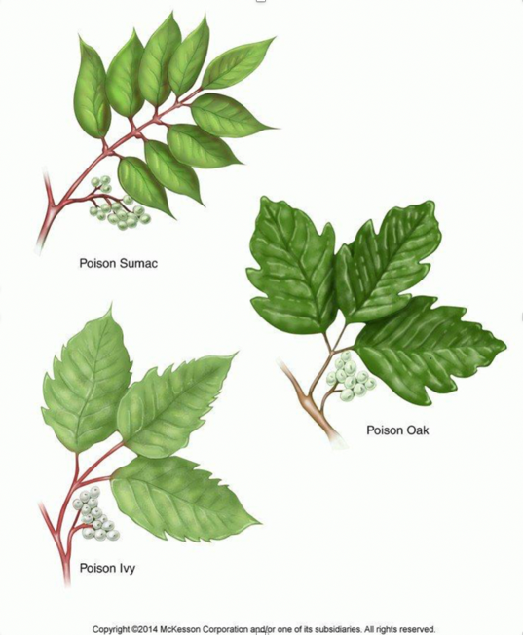

For information on how to identify these plants, as well as treatment options after exposure, go to: https://www.summitmedicalgroup.com/library/adult_health/aha_poison_ivy_oak_and_sumac/

DO NOT BURN any of these plants! If the smoke is inhaled it can cause an extremely painful and possibly fatal rash on the lining of the lungs.

Garbage and Recycling

All members of the WDLPOG are entitled to use the Solid Waste & Recycling Site at the top of West Devil Lake Lane. Permission to use this site, which is on private property, was granted by a WDLPOG member. However, if the site is not kept clean and free of items that may attract bears or other wildlife, the permission may be revoked. Please make sure that you and your guests use the site properly.
- The bins have limited capacity, so please make best efforts to minimize your waste, and, on Tuesdays, take your garbage and recyclables to the Salem Waste Disposal and Recycling Site on Devil Lake Road (see below)
- All garbage must have a visible and firmly affixed Township of South Frontenac purple bag tag around the neck of the bag. One full tag per bag. Untagged items will not be picked up. All owners with a residence on their property receive an annual allotment of 50 tags with their Interim Tax Bill in March of each year. If you have not received these by the end of March, please contact the Township at: http://www.southfrontenac.net/en/living-here/property-taxes.asp to verify your information. Landlords are required to supply their tenants with tags for their rental units. For information about South Frontenac garbage bag tags visit: http://www.southfrontenac.net/en/living-here/bag-tags.asp?_mid_=13046 or call the Facilities & Solid Waste Department at 613-376-3027 x4330
- All recyclables must be rinsed and sorted into the correct bins. Remove recyclables from any bags before putting them into the bins
- Cans, cereal boxes, etc., should be crushed to increase bin capacity. There is a can crusher on site
- Note the difference between boxboard (e.g. cereal boxes), which goes in the paper bin, and corrugated cardboard, which goes in its own designated bin and must be bundled with tape or twine into stacks with maximum dimensions of 2 feet x 3 feet x 8 inches
- Close all bins securely after use to avoid attracting animals.
- If the bins are full, do not put garbage/recycling into another bin or on the ground. Take it with you to dispose of properly elsewhere
- If you do not want to return them yourself, put returnable items such as liquor, wine and beer bottles and cans in the returnable bin. If you happen to be going to the beer/liquor store, please take the bottles and cans from the bin with you (and keep the change)
- If you have any questions about how to use the site, please contact the WDLPOG Board at wdlpog@gmail.com

Landfill Locations & Hours of Operation: For information about South Frontenac Waste Disposal Sites (WDS), go to: http://www.southfrontenac.net/en/living-here/landfill-locations-and-times.asp This website also provides information about what kinds of items the WDS accept. All WDS within the Township are only for the use of Township of South Frontenac residents.

Salem Waste Disposal and Recycling Site: 1779 Devil Lake Road. Whenever possible, use this site to dispose of garbage and recyclables. Larger bagged items that do not fit into the WDLPOG green waste bins can also be taken here. Note that this site only accepts recyclables and bagged and properly tagged household garbage.
Hours of Operation: Tuesday: 8:30am-4:30pm.

Loughborough Waste Disposal Site: 1818 Norway Rd, Perth Road
Payment at this WDS is by truckload or, for large items, per piece.
Do not bring tagged domestic garbage to this site - charges will be levied.
Hours of Operation: Monday & Saturday: 8:30am-4:30pm

Portland Waste Disposal Site: 6085 Road 38, Verona
Payment at this WDS is by weight of goods. A flat rate of $20 is charged for the first 200kg (440lbs). There is no charge for metal, cardboard, yard waste (up to 6” in diameter) or tires.
Do not bring tagged domestic garbage to this site - charges will be levied.
Hours of Operation: Wednesday & Saturday: 8:30am-4:30pm

Credit cards are not accepted at either WDS. The Loughborough WDS only accepts cash or personal cheques (with photo I.D.). Portland WDS also accepts debit cards.

Household Hazardous Waste (HHW) Facility: 2491 Keeley Rd, Sydenham, across from the Public Works yard
Acceptable HHW items can be taken here. For more information, go to: http://www.southfrontenac.net/en/living-here/household-hazardous-waste.asp
or contact the Facilities & Solid Waste Department at 613-376-3027 x4330.
Hours of Operation: Thursday: 3:00pm-7:00pm.

Being Good Neighbors

Get Involved in WDLPOG:
- Attend the Annual General Meeting (AGM) and pot luck picnic to meet your fellow members
- Pay your dues every year prior to the AGM. This will give you voting rights at the AGM and facilitate necessary road maintenance
- Become a volunteer on special projects
- Volunteer your time and expertise by participating on the Board of Directors

Get Involved in South Frontenac:
● Municipal Elections: Canadian residents who own property in South Frontenac
Township can vote in the municipal elections either in person, via the Internet, or by mail

Adhere to the Noise Bylaw of South Frontenac:
- The Bylaw prohibits at all times the use of any electronic device containing a loudspeaker, “the sounding of any bell, steam or air whistle, horn, siren or signal device,” and the use of a motor vehicle that emits “banging, clanking, squealing or other like sounds,” or that lacks “an effective exhaust or intake muffling device in good working order.”
- From the hours of 11pm to 7am Monday through Saturday & 11pm Saturday to 9am Sunday “yelling, shouting, hooting, whistling or singing” and “the operation of any powered or non-powered tool for domestic purpose” are prohibited.
- The discharge of Fireworks is only permitted from the Friday through the Monday of the Victoria Day weekend, and from July 1st through July 4th (as long as there is no fire ban in effect).
- To lodge a complaint, call: 613-541-3213. This is an answering service, so you will have to leave a message, including your name, phone number and details of the complaint.
- See Handbook Addendums for complete Township of South Frontenac Noise Bylaw.

Keep Guests/Renters Informed:
Please provide a printed copy of this handbook as a reference for all guests and/or renters, to ensure their compliance with community and South Frontenac rules. Special emphasis should be placed on emergency information and the proper handling of garbage/recycling.

Map of West Devil Lake

